Practical no 6
Code:-
for i in range(1,6):
print("*"*i)
Output:-
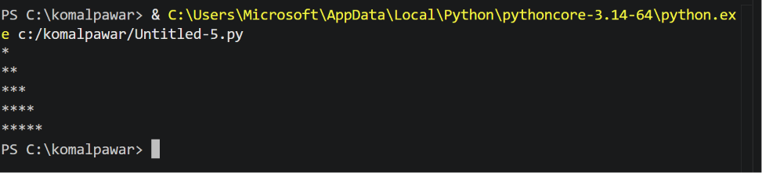

Exercises
Q1.write program that uses a nested loop structure to generate a right angled triangle pattern of incrementing numbers ,where each row displays its corresponding row count index
Code:-

row = 5
for i in range (1,row + 1):
for j in range(1,i + 1):
print(i , end=" ")
print()
Output:-
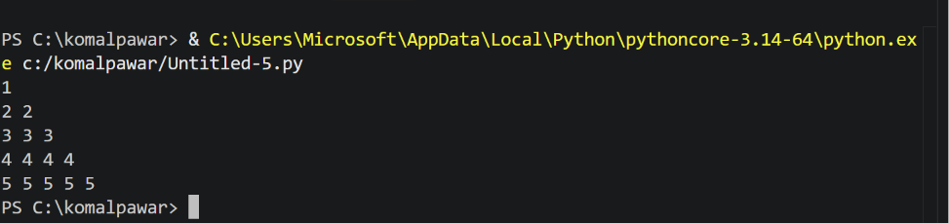
Q2.Build a script that print a clean , text –based invoice frame border using rows and columns of asterisk (*)character
Code:-
rows = 7
cols = 30

for i in range(rows):
for j in range (cols):
if i == 0 or i == rows - 1 or j == 0 or j == cols - 1:
print("*", end="")
else:
print(" ", end="")
print()
Output:-
